## **Nmap & Scapy Practical Lab Documentation**

### **Overview**

**This lab demonstrates hands-on network scanning and packet manipulation using Nmap and Scapy. The goal is to validate fundamental skills in host discovery, service enumeration, OS fingerprinting, and packet-level analysis.**

## **1. Environment Setup**

* **Host OS: Kali Linux**
* **Tools Used:**
* **Nmap (7.x)**
* **Python 3 + Scapy**
* **Target: Local test network / virtual machines**
* **Permissions: All scans performed in an authorized lab environment.**

# **2. Nmap Exercises**

### **2.1 Host Discovery**

**nmap -sn 10.6.6.1/24**

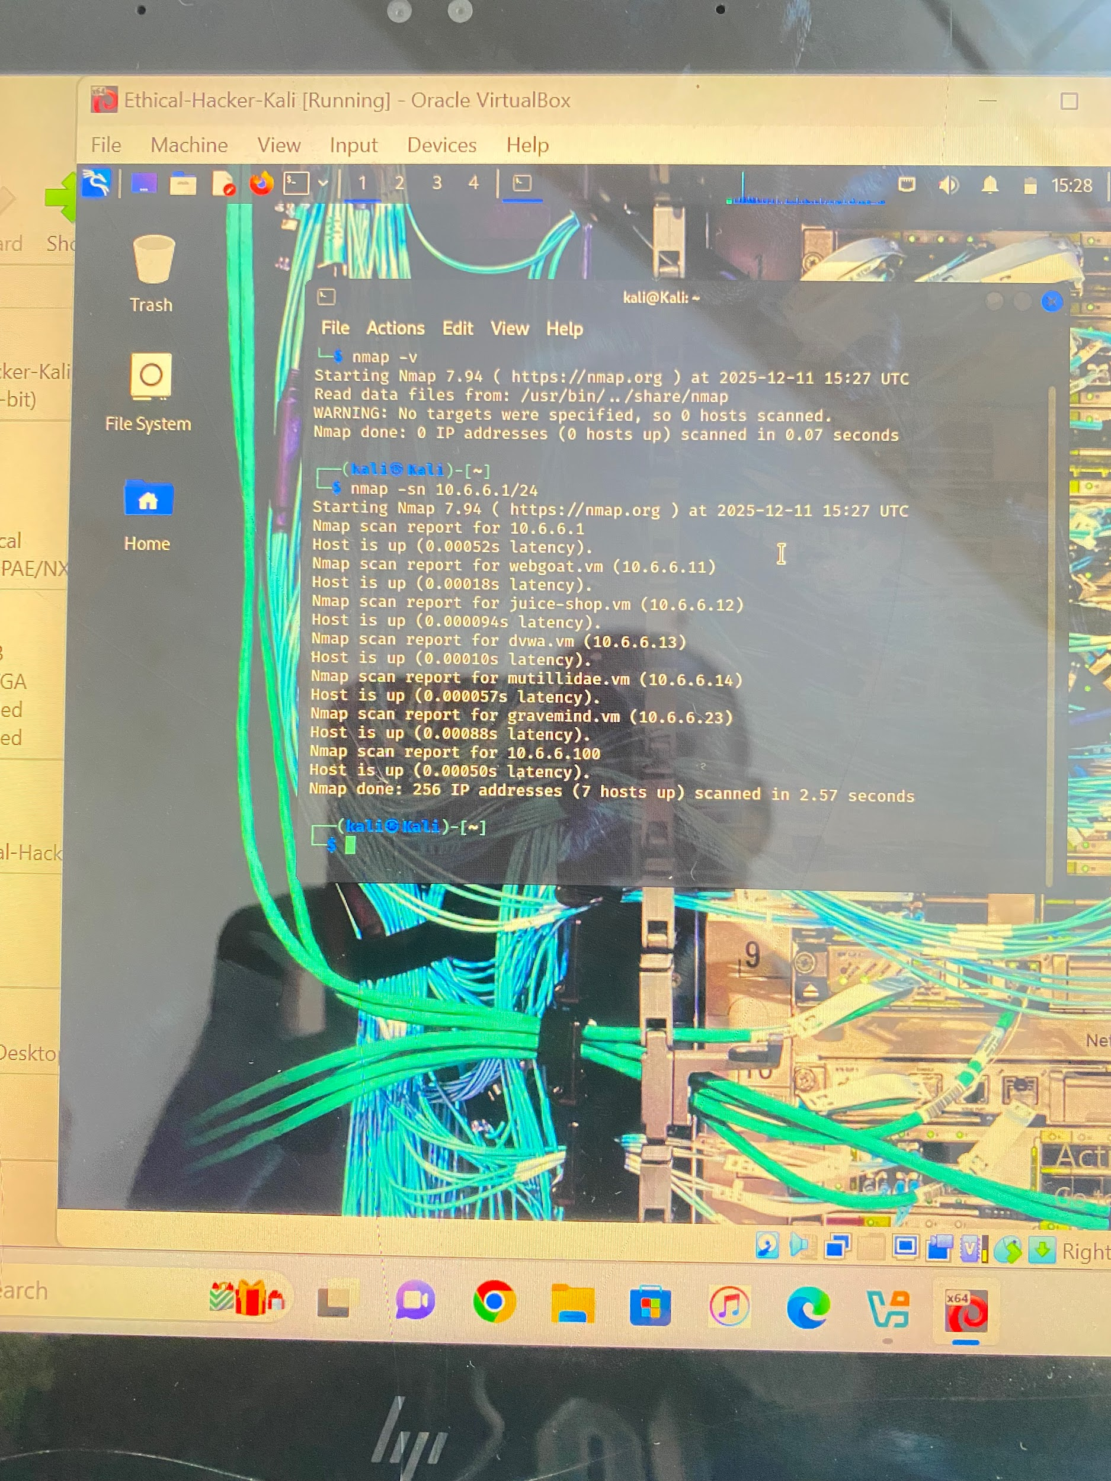

**Result:**

* **Hosts responding to ARP/ping appear as “Host is up”.**

### **2.2 Basic Port Scan**

**Sudo nmap -O 10.6.6.23**

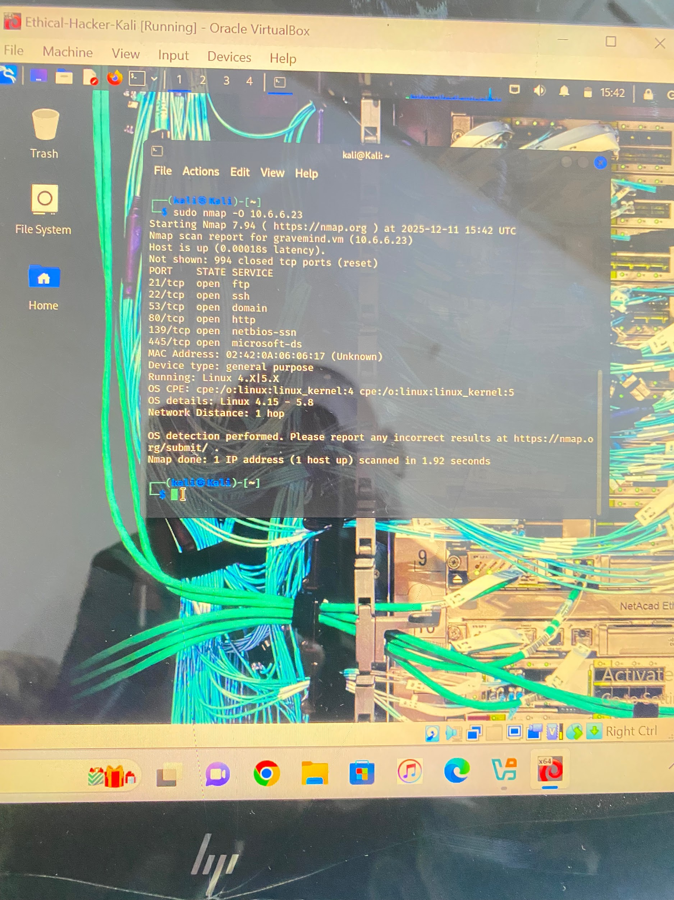

**Result : Detects open TCP ports.**

### **2.3 Full TCP Port Scan on port 21**

**Nmap -p21 -sV -A -T24 10.6.6.23**

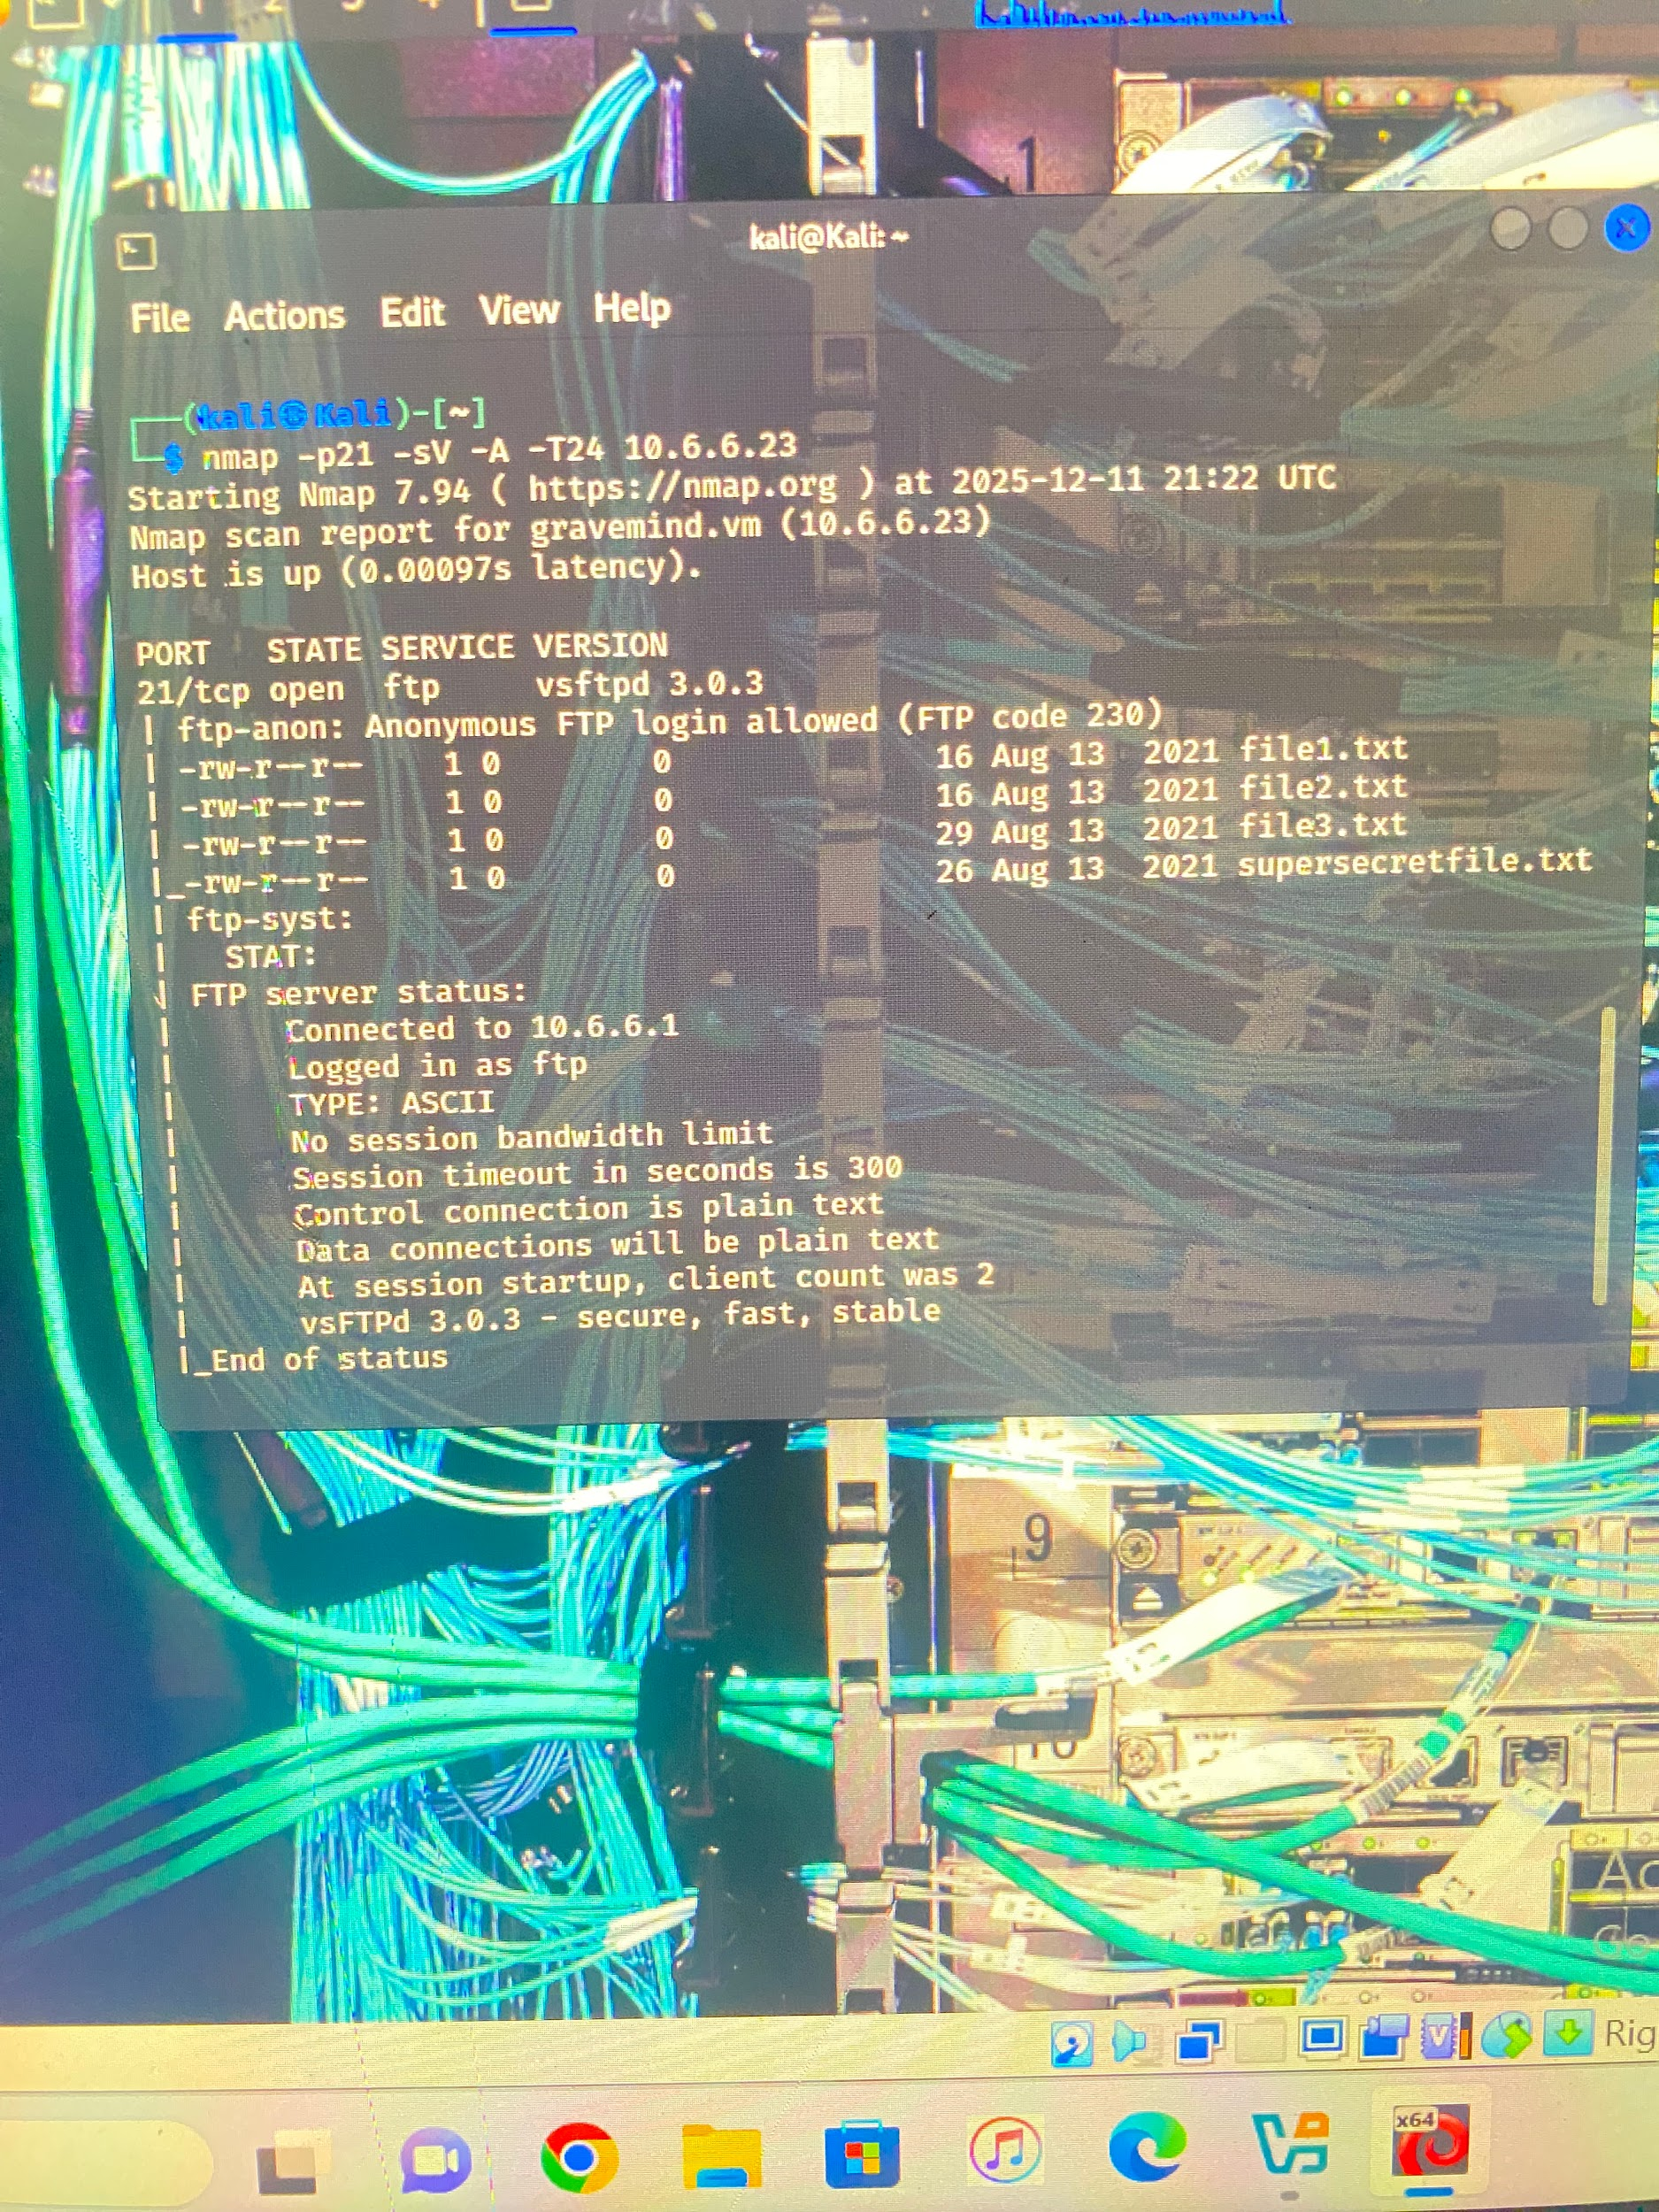

**Result: port 21 has 4 files (files.text)**

### **2.4 Aggressive Scan on port 139 and 445**

**nmap -A -p139,445 10.6.6.23**

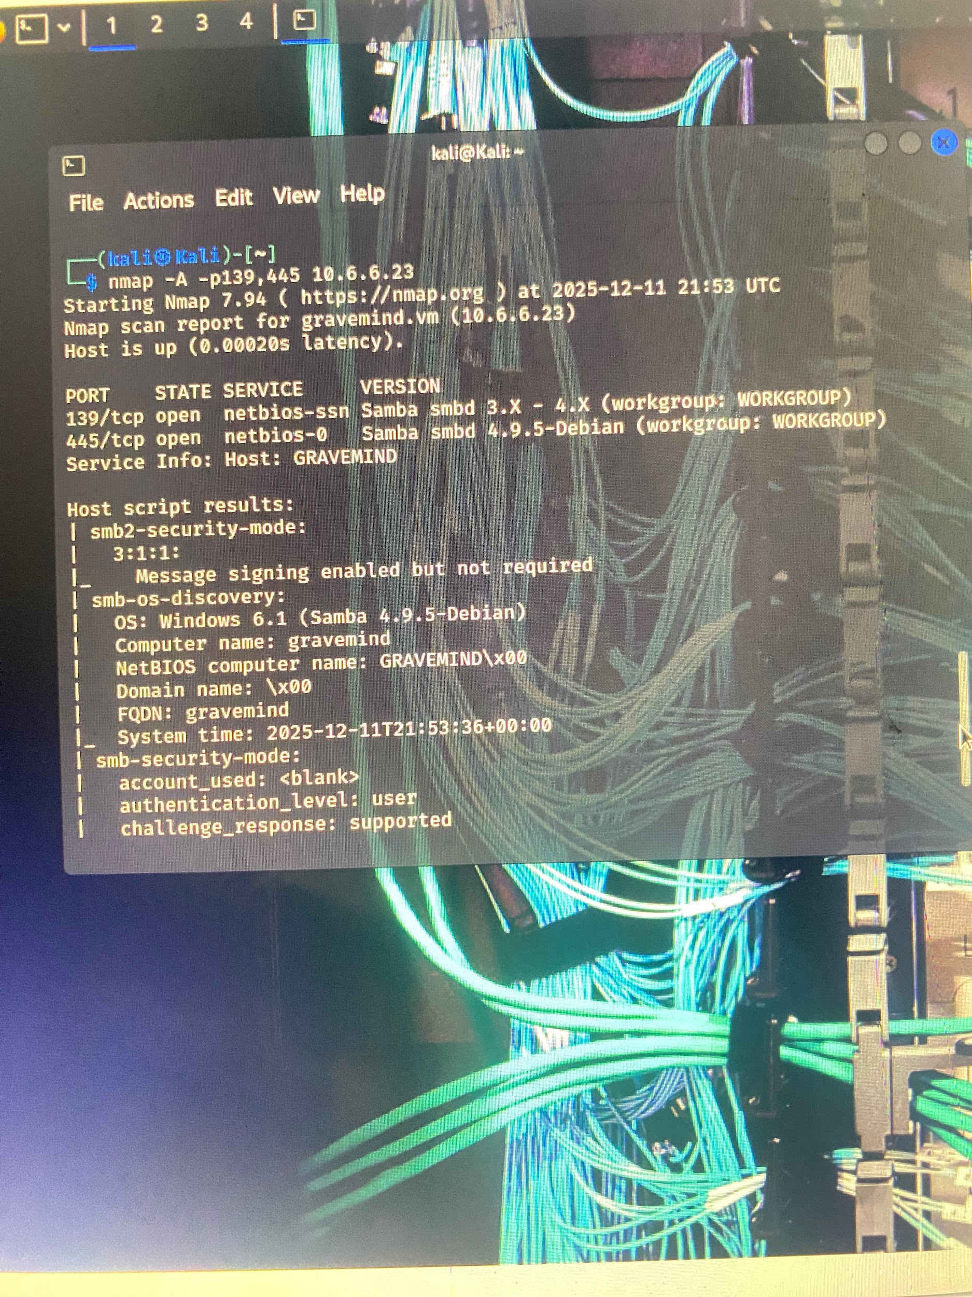

**Result: it shows that port 139 run on netbois-ssn samba and port 445 runs on netbois-O samba**

**It also shows the OS they run which is windows 6.1 (samba 4.9.5 debian)**

# **3. Scapy Exercises**

**Firstly we need to talks about scapy**

**Scapy is a powerful Python-based packet manipulation tool used mainly in networking and cybersecurity. Scapy lets you create, send, capture, analyze, and modify network packets directly from Python.**

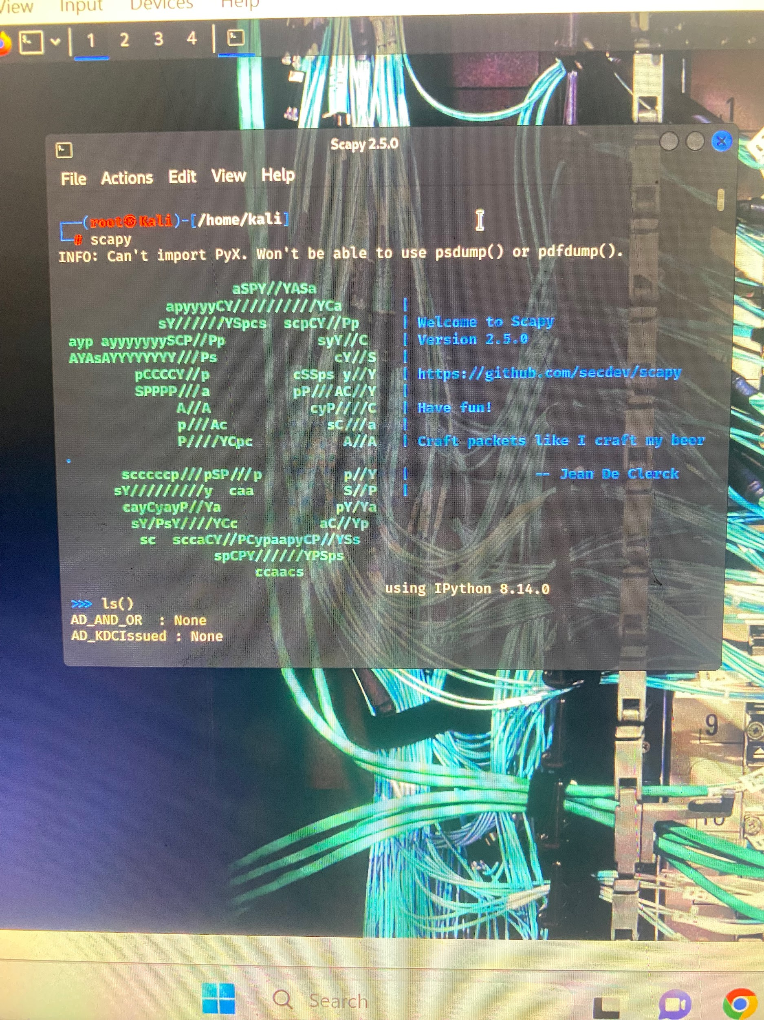

**So before we can run scapy command we need to be in administrative mode**

**To be in administrator mode we need to run a command**

**Sudo su**

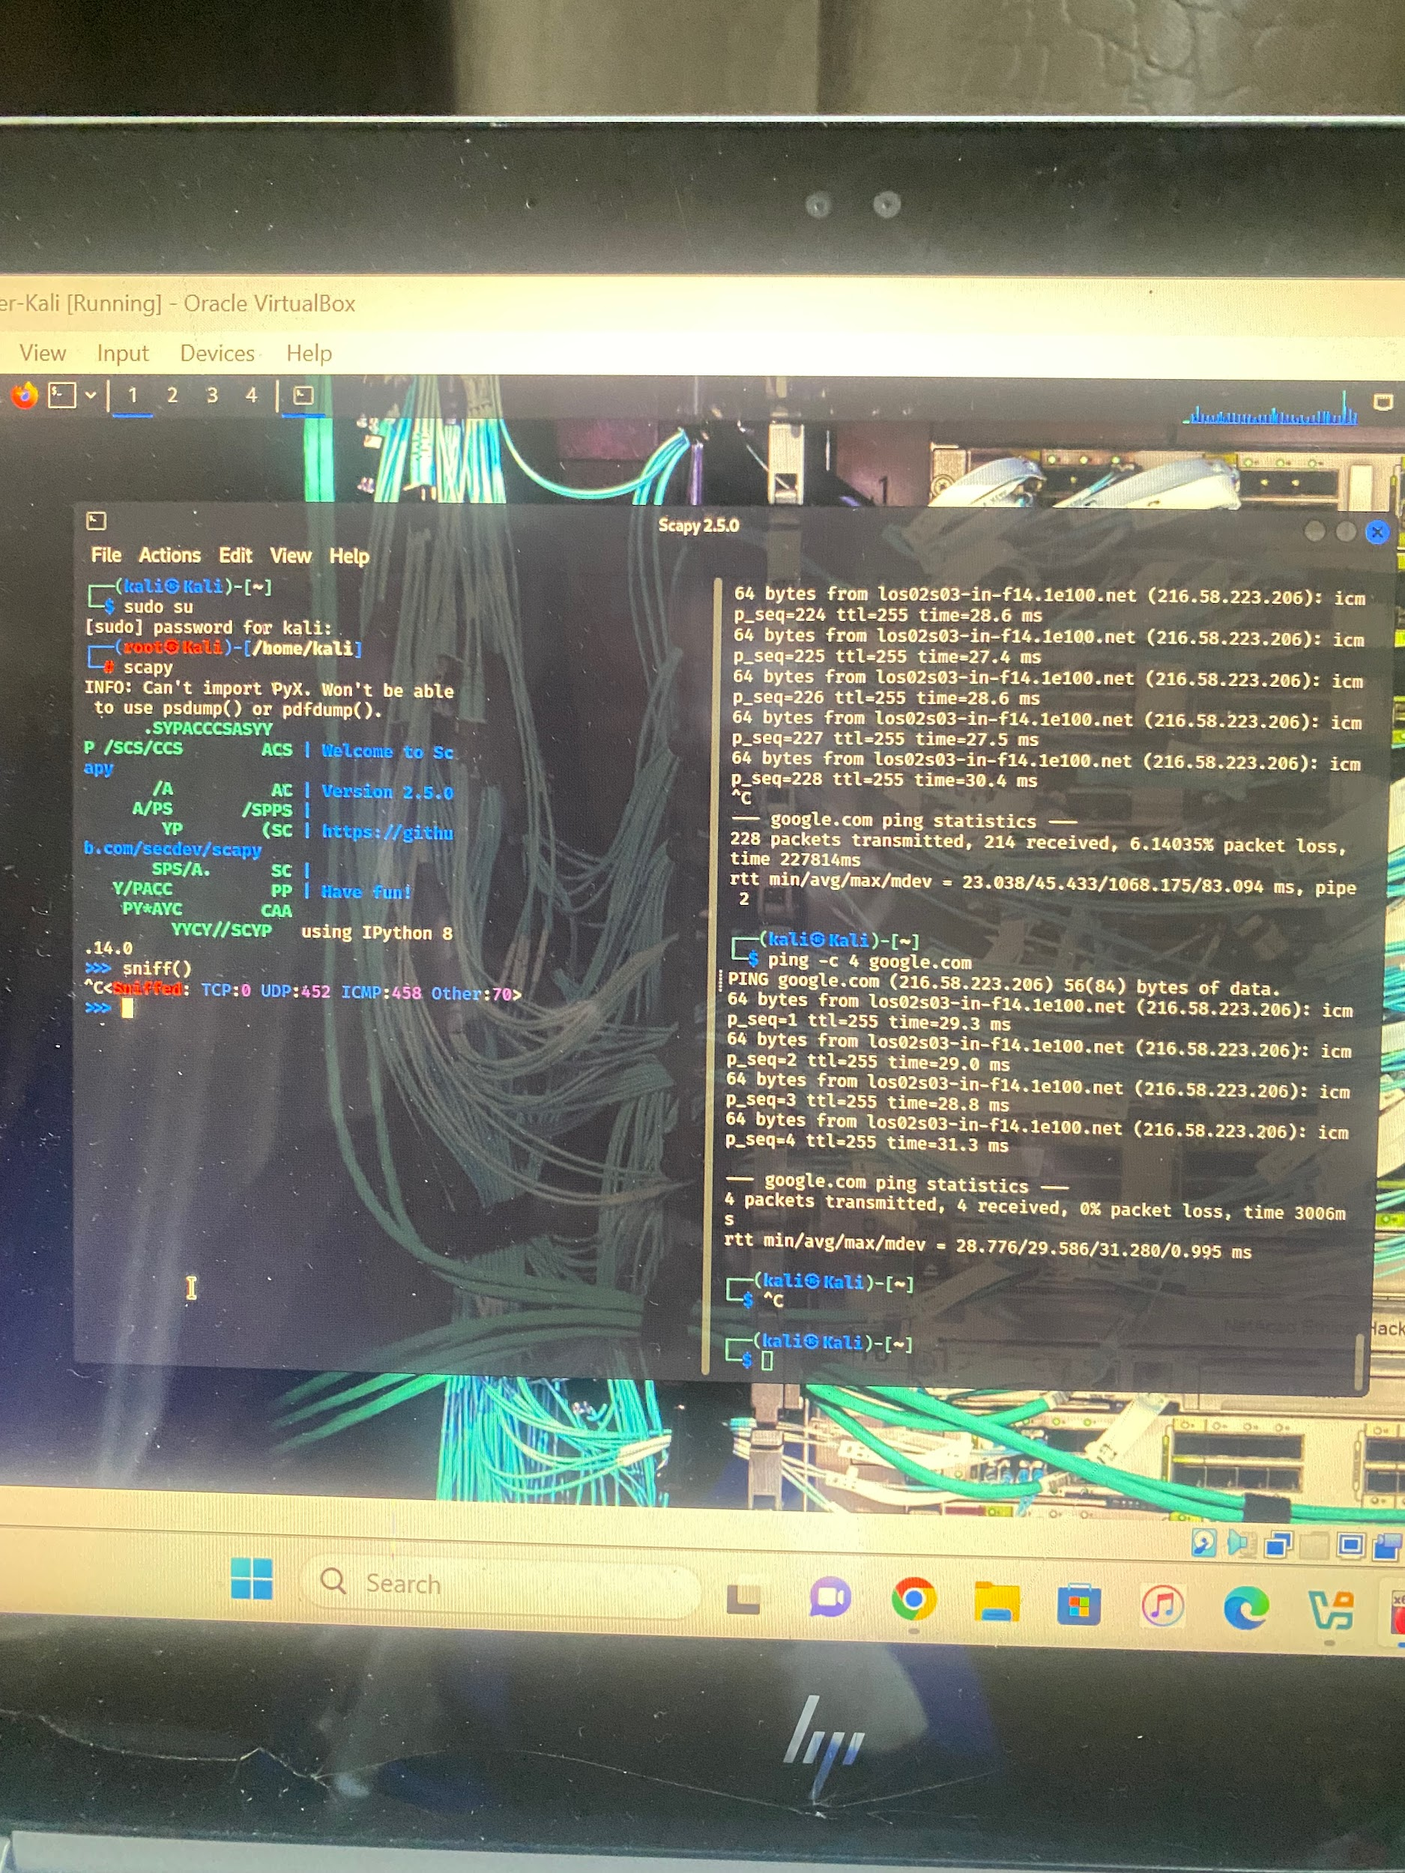

**Now we can run a sniff command**

**Sniff()**



**Then you ping any website e.g ping** [**google.com**](http://google.com)



**The ping can be specific e.g ping -c 4** [**google.com**](http://google.com) 

**Stop the sniff by using ctrl+c**

**Then assign the sniff packet to a variable using**

**Paro=_**

**Then to check the data of the sniff packets you run a command**

**Paro.summary ()**

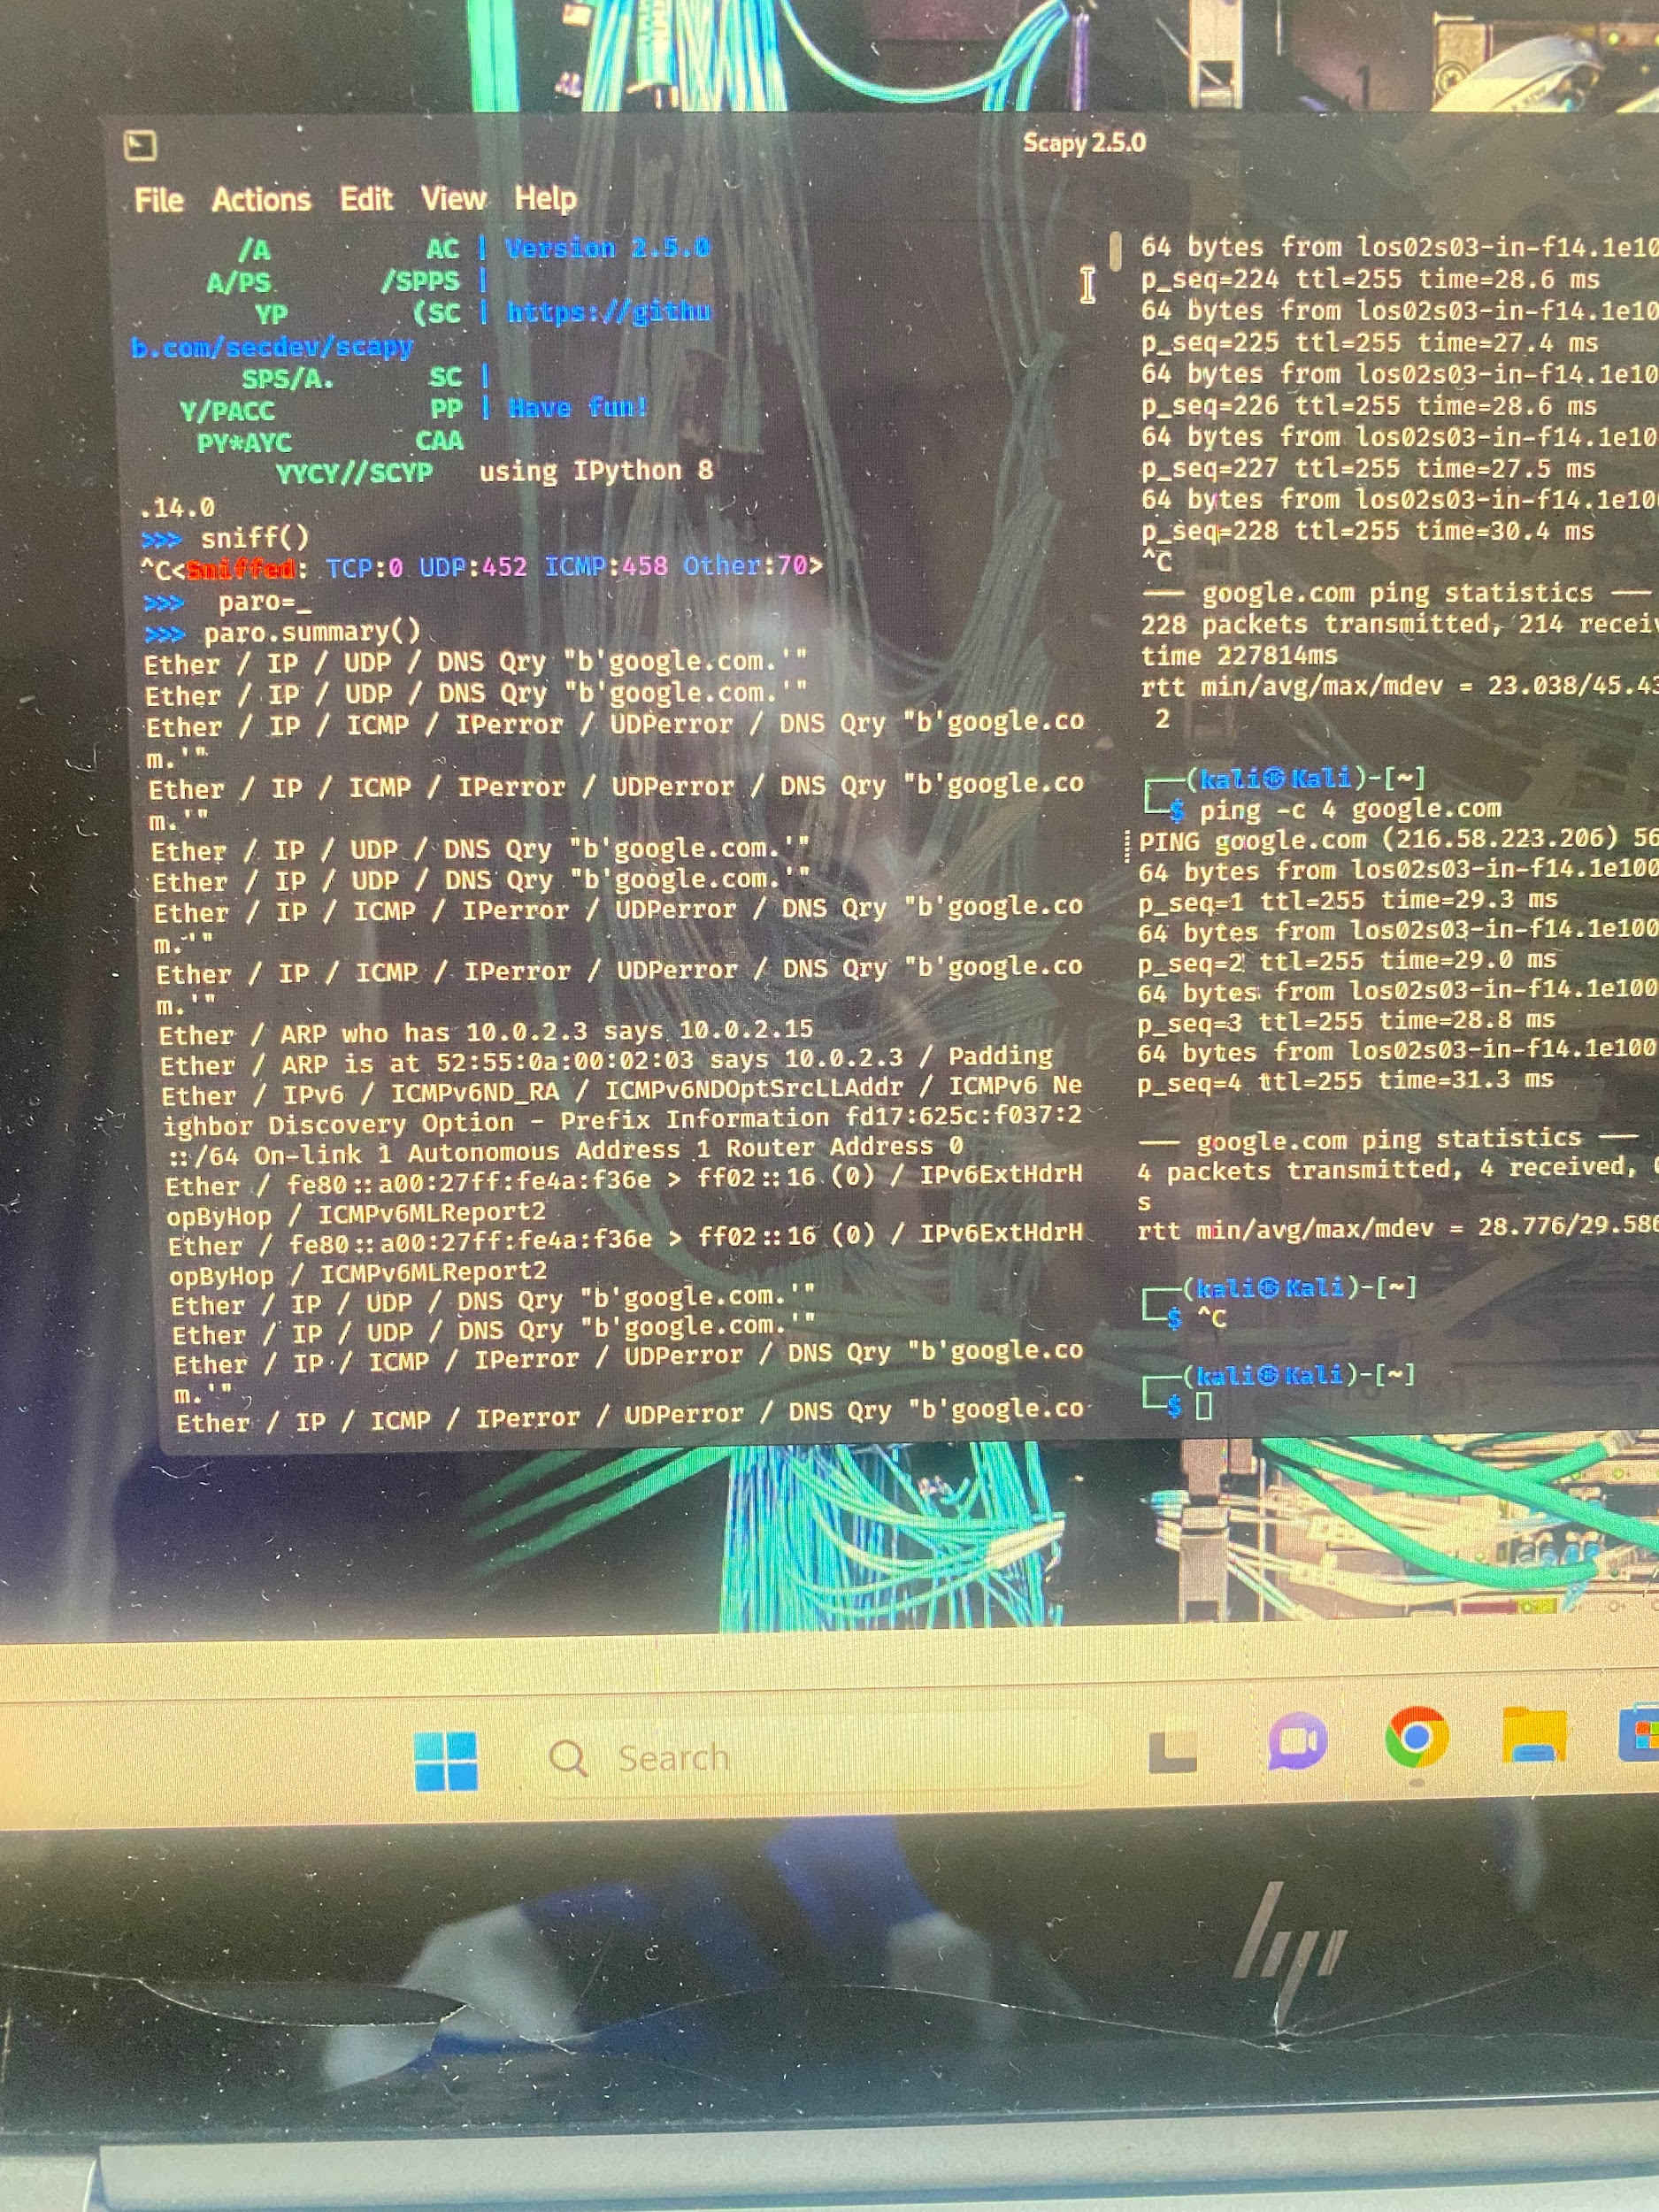

**This are the packets sniff from the last command**

**Sniff can also be done into just on the internal interface**

**To do thet you need to run a command to get the internal interface of the host**

**Ifconfig**

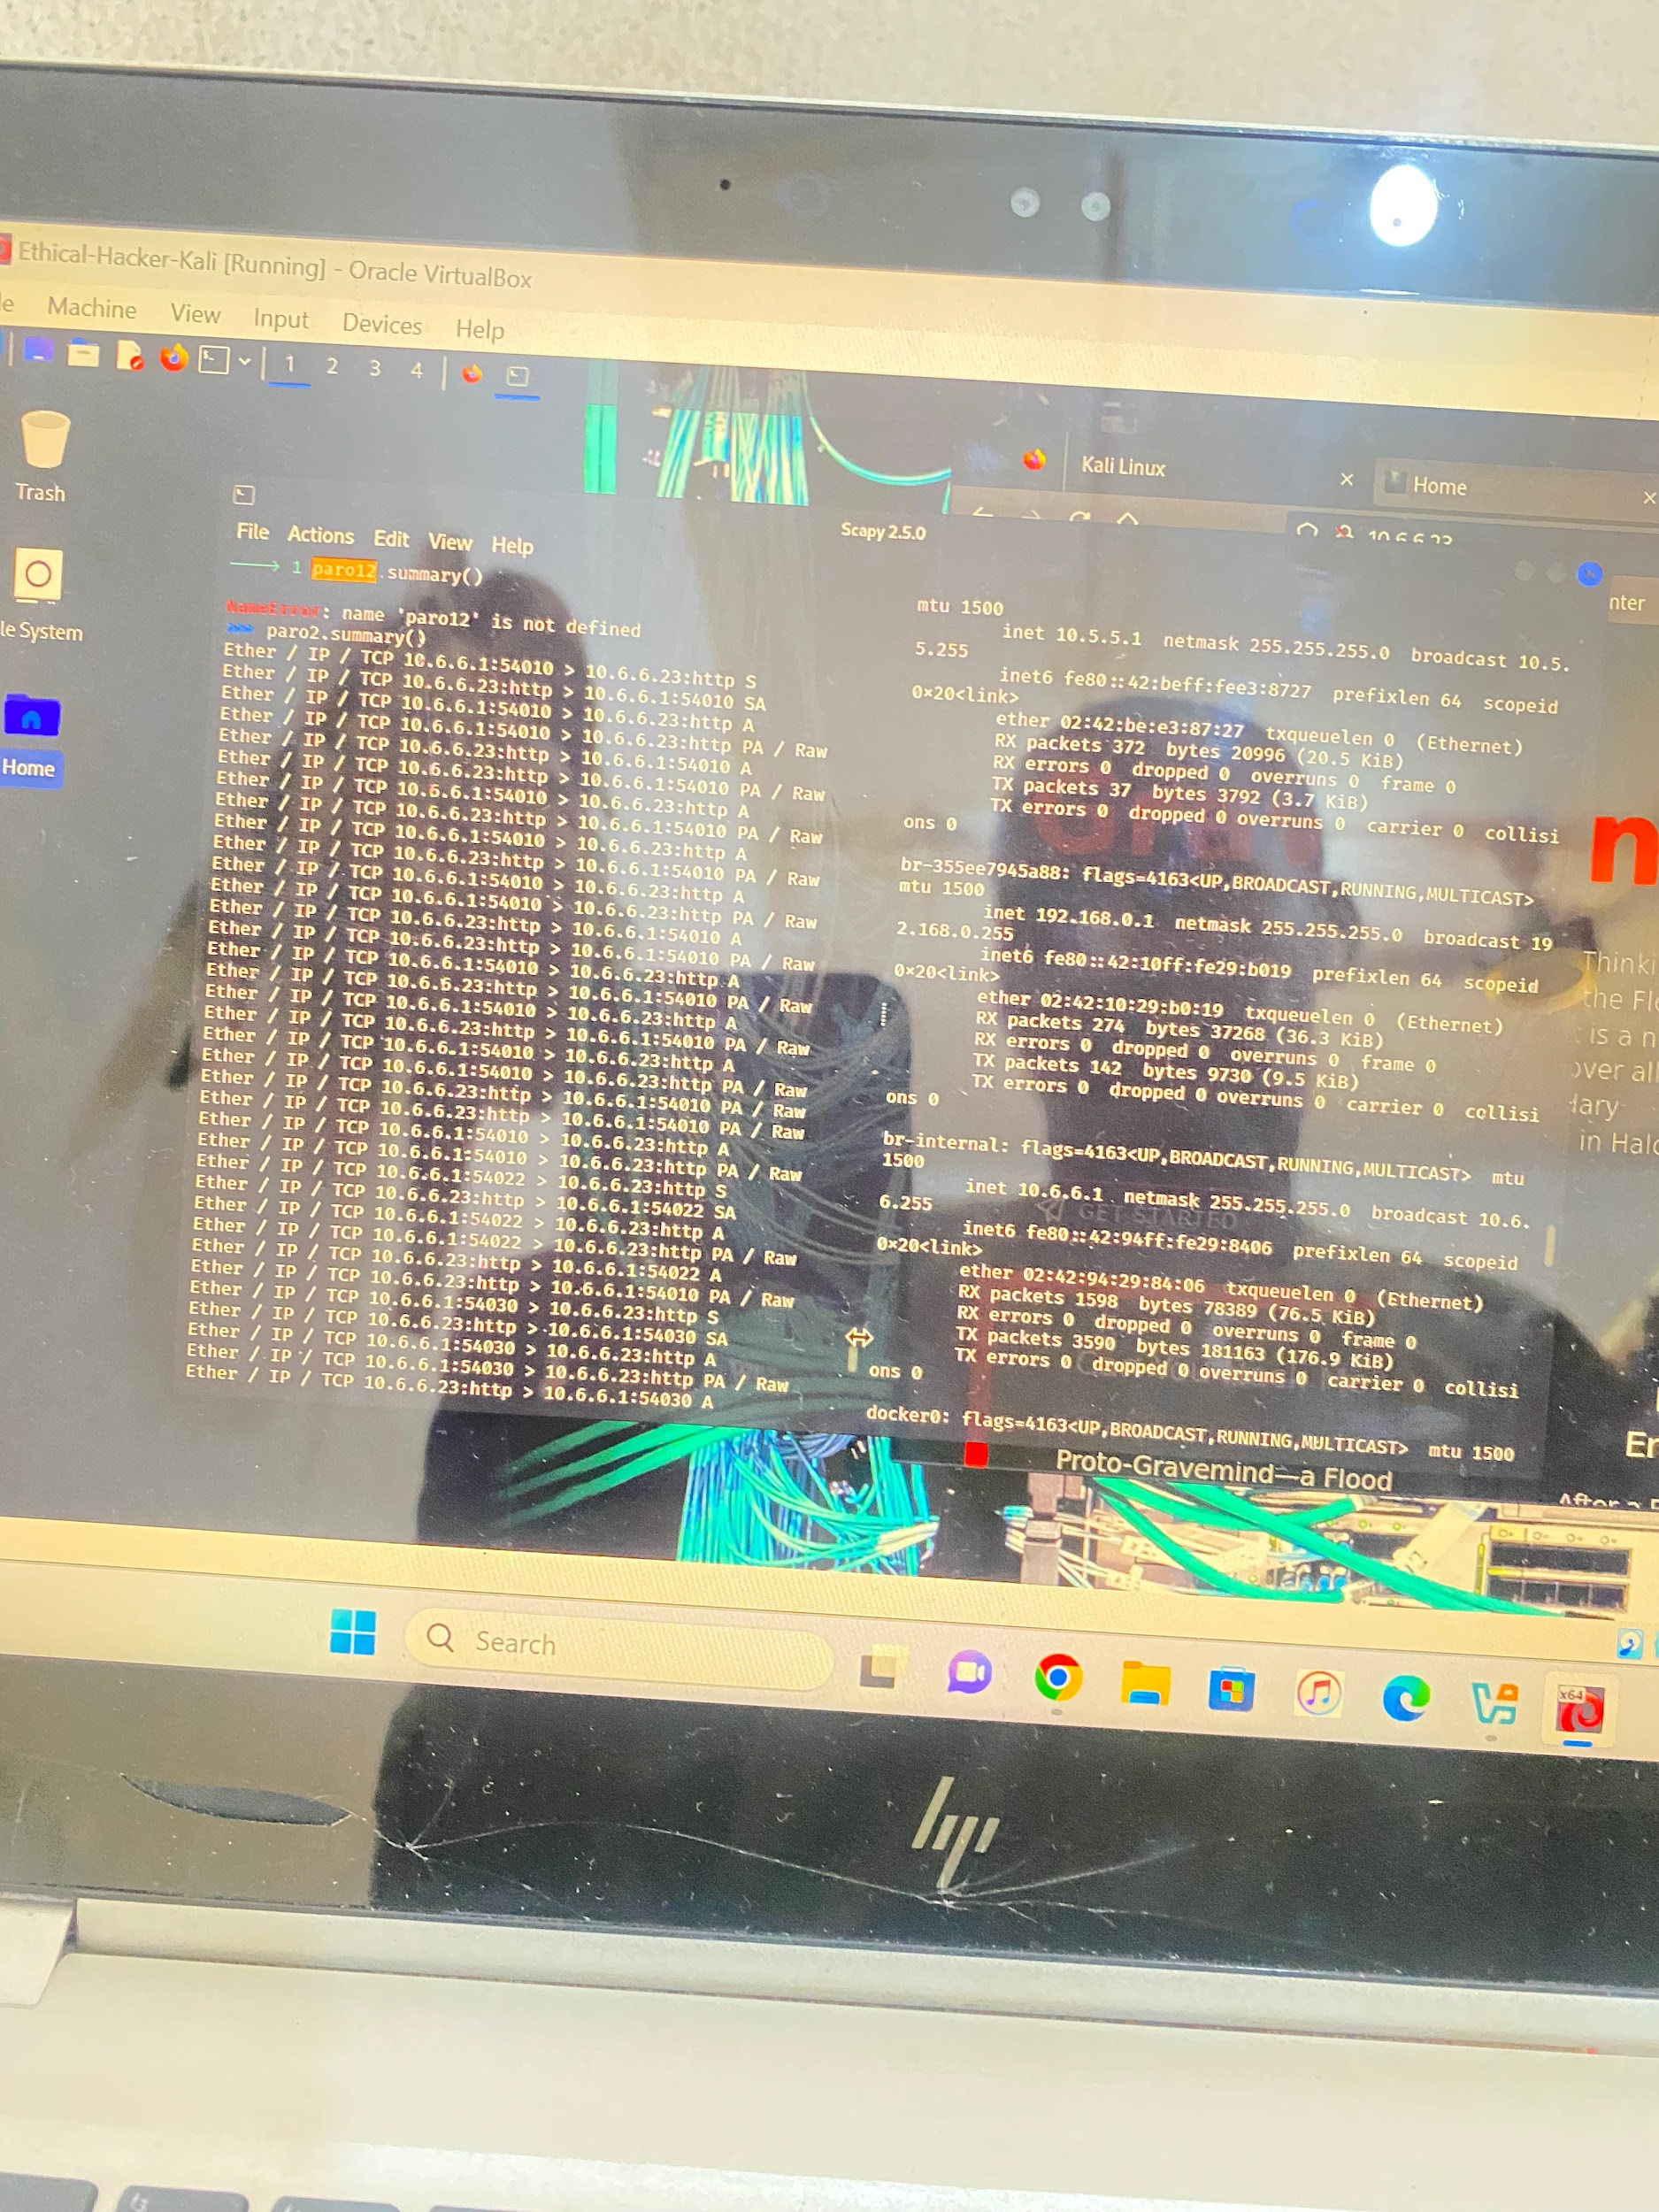**result : this show the packet of the specified inter interface (br-internal) which is 10.6.6.1**

### **Packet Analysis**

**You can run a command to sniff on just the internal interface**

**“Sniff(iface=“br-internal”)” by clicking enter**

**The sniff has started all you need to do now is to open any browser e.g Mozilla from the VM and visit an inbuilt website.**

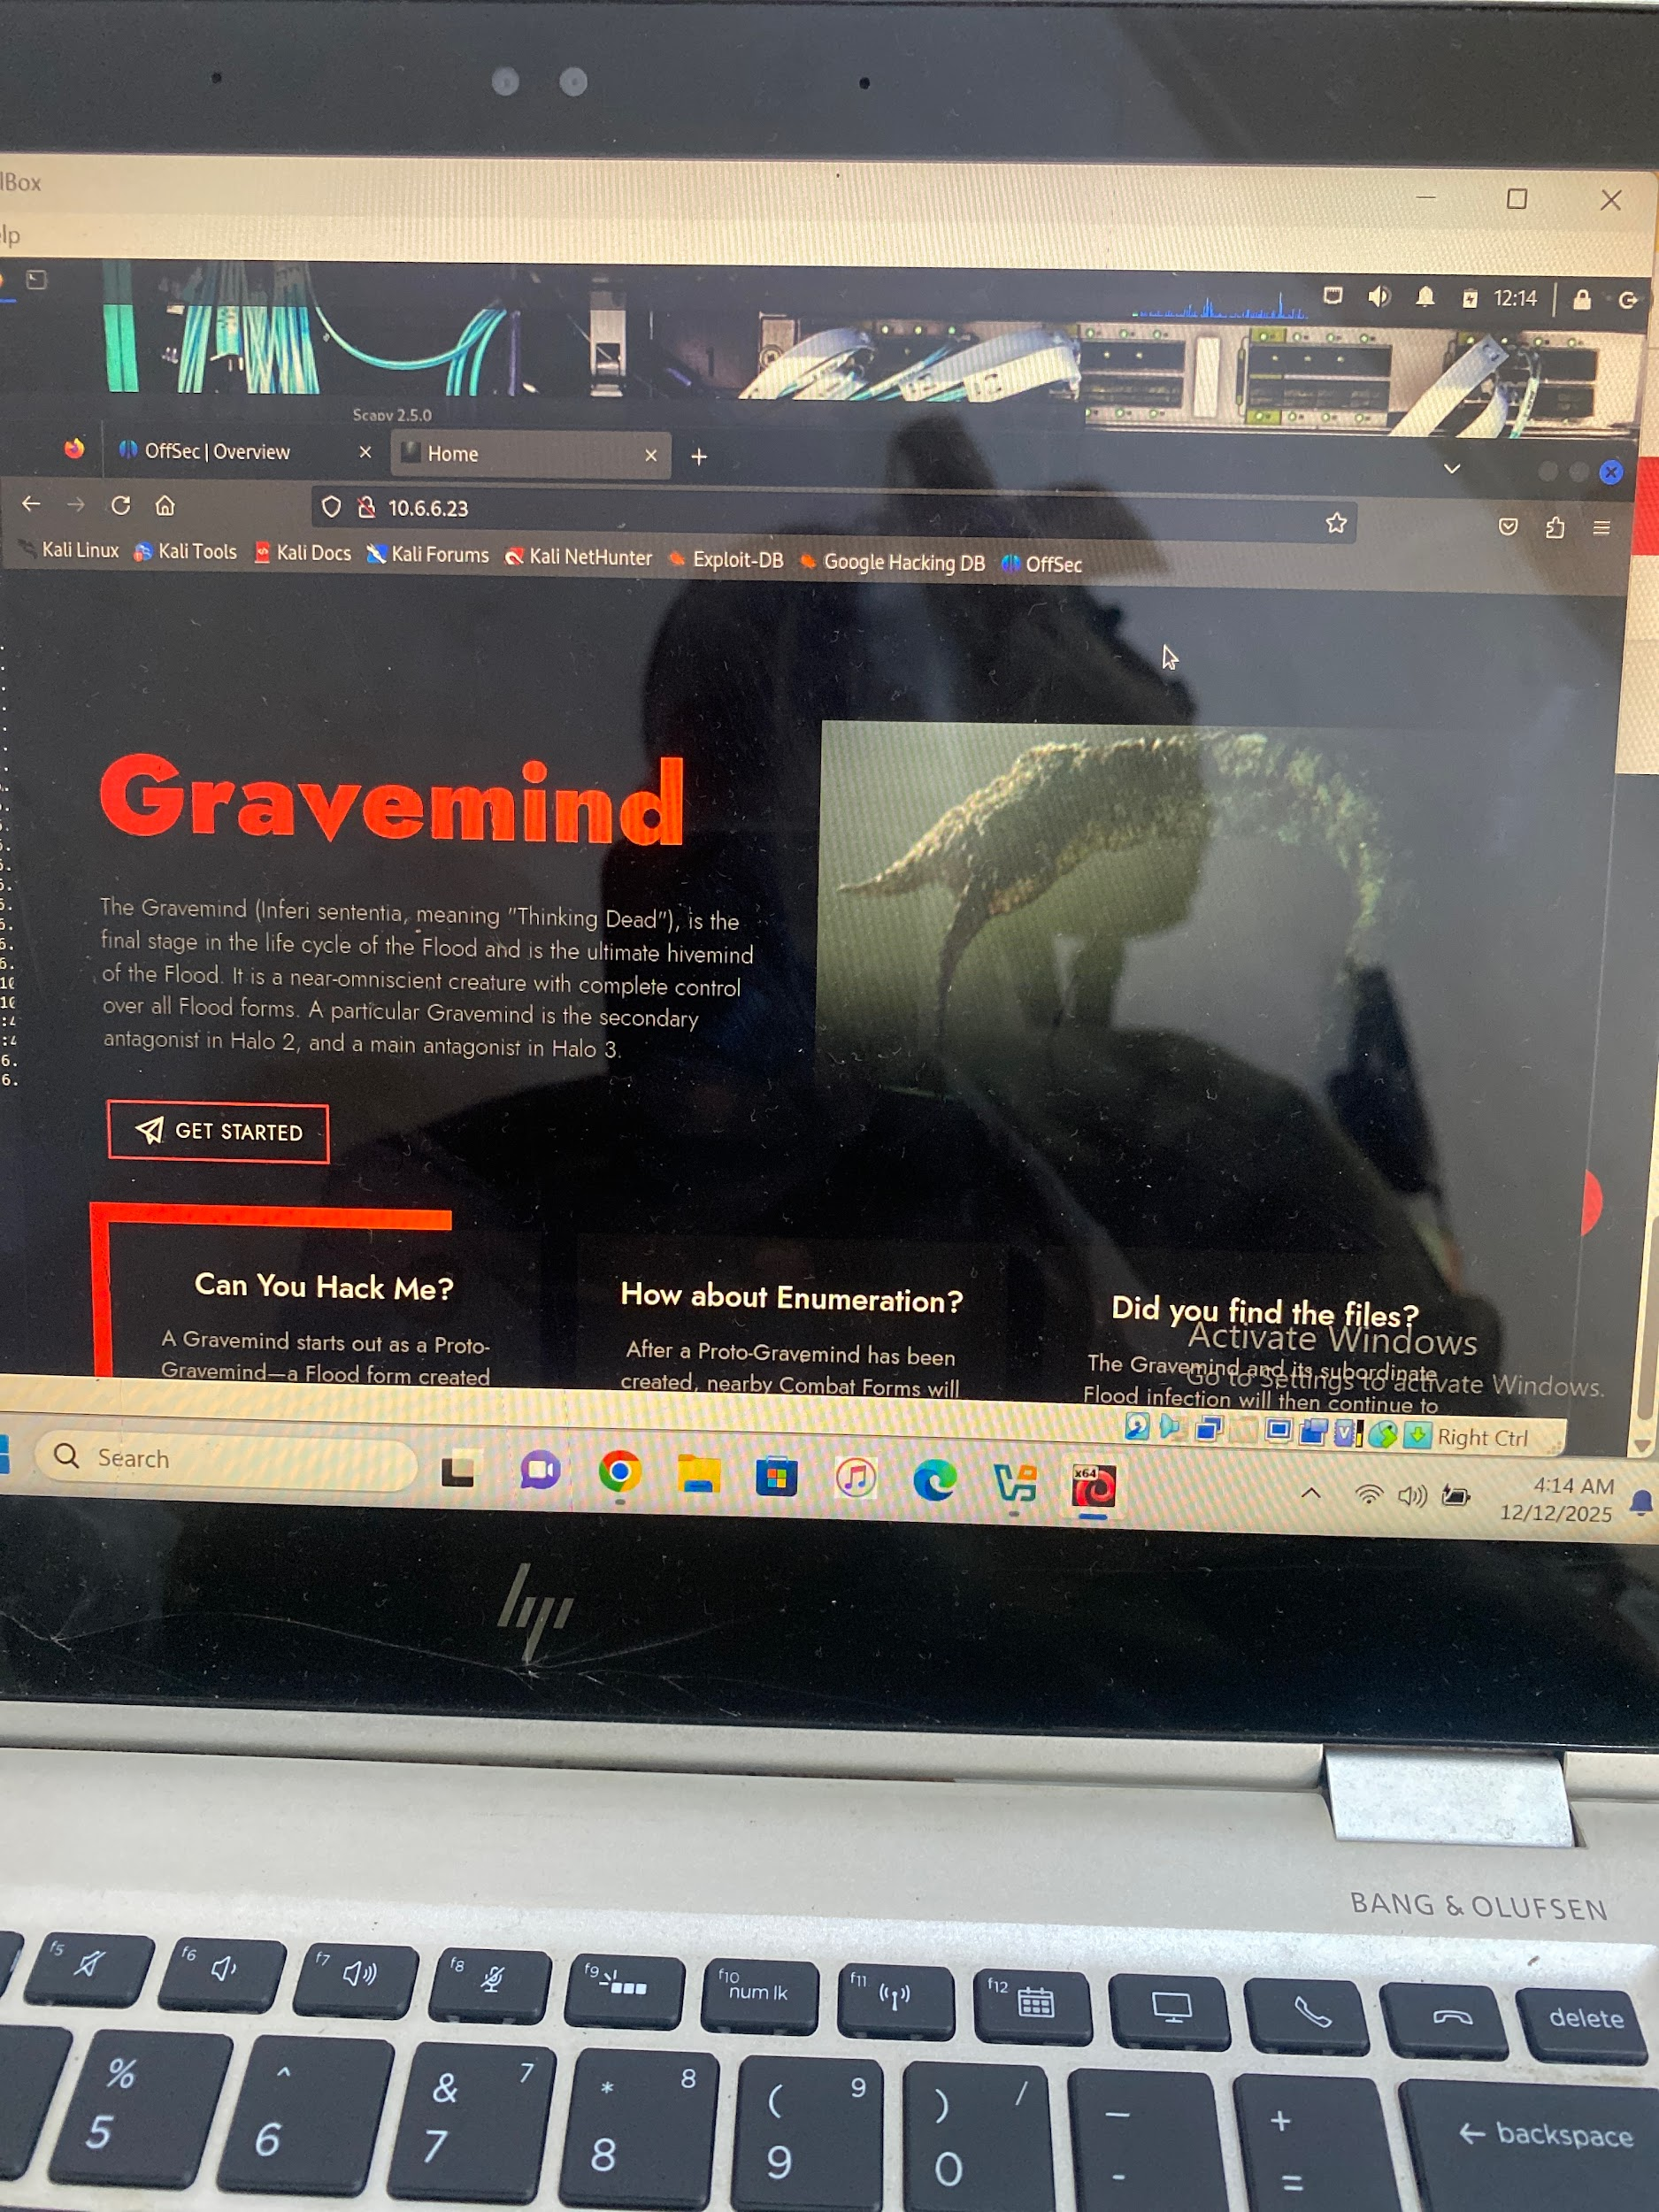

**After visiting an inbuilt web then go back to where you’re sniffing to stop it by using ctrl+c**

**After that you assign the packet to a variable**

**E.g “Paro4=_”**

**Then run a command “ Paro.summary” to show the packet output**

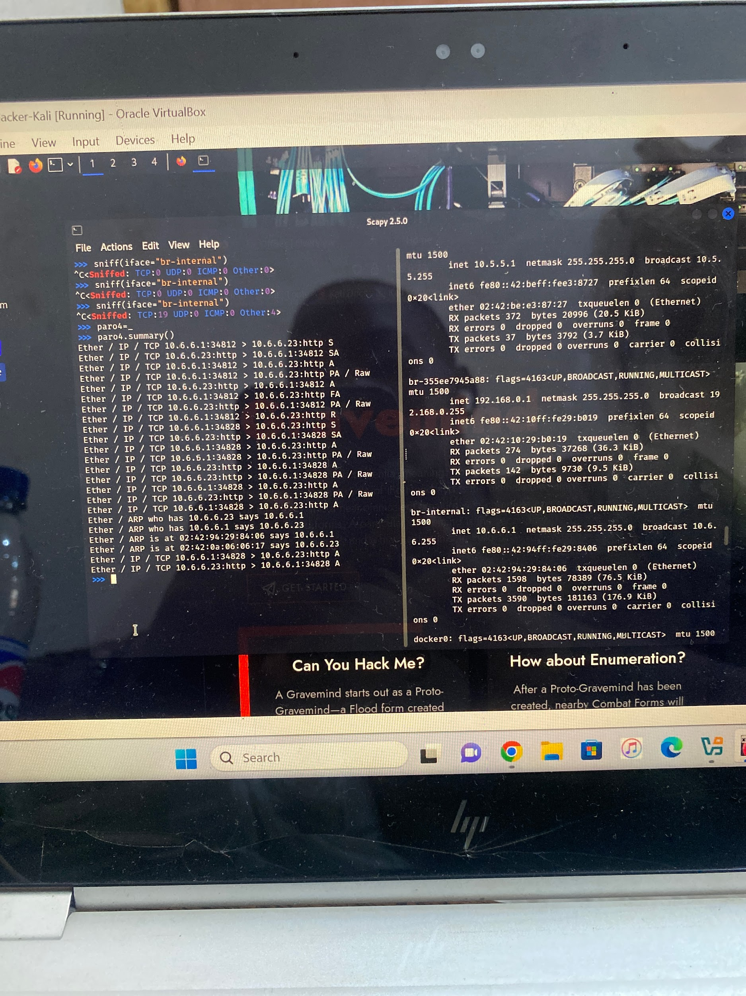

**Results: this shows the packet output of the last command run .**

# **Summary of Results**

* **Nmap successfully identified open ports, service versions, and OS fingerprints.**
* **Scapy allowed custom packet creation and real-time packet capture.**
* **Both tools reinforce core networking and security fundamentals.**